https://github.com/YangfanZhang/CoderByteNotes/blob/master/Java%20Age%20Counting



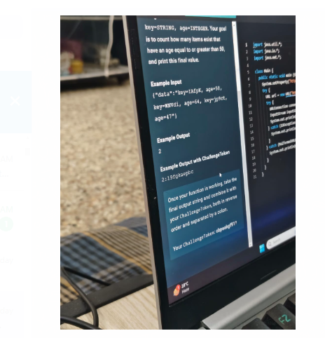

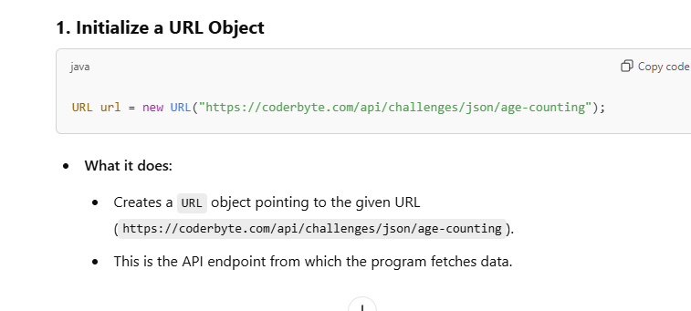

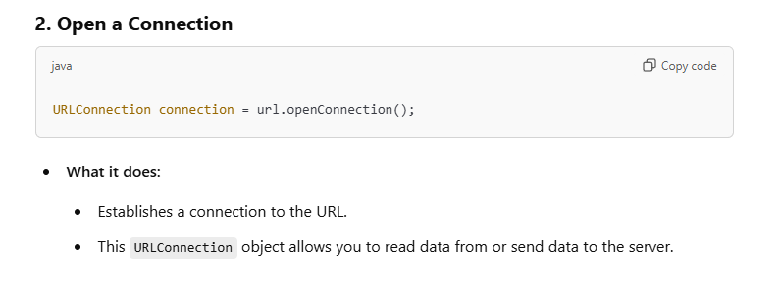

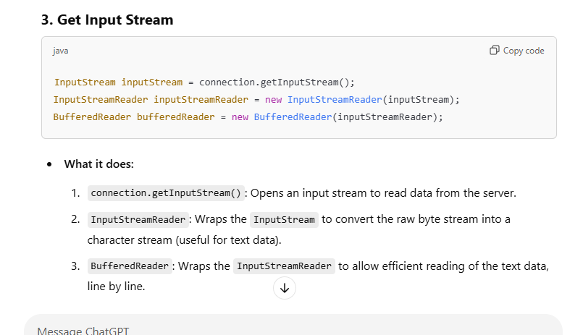

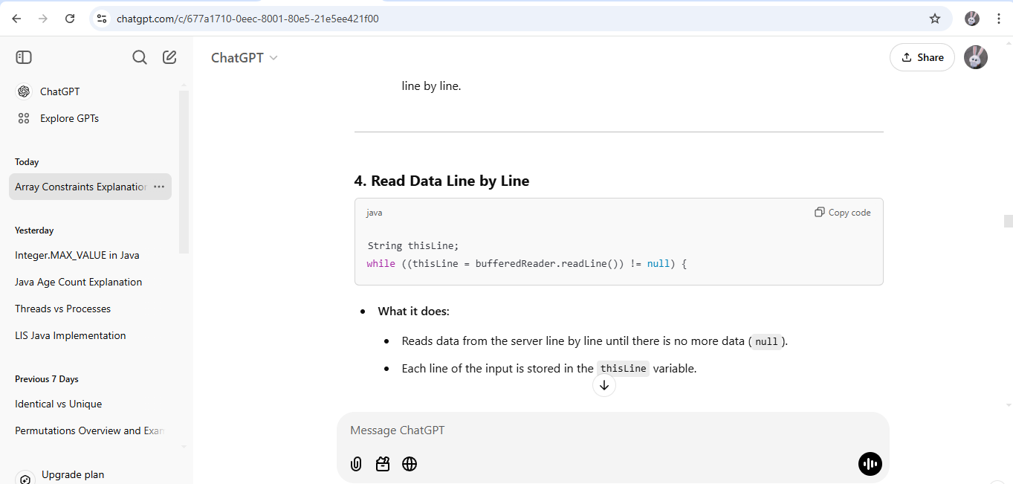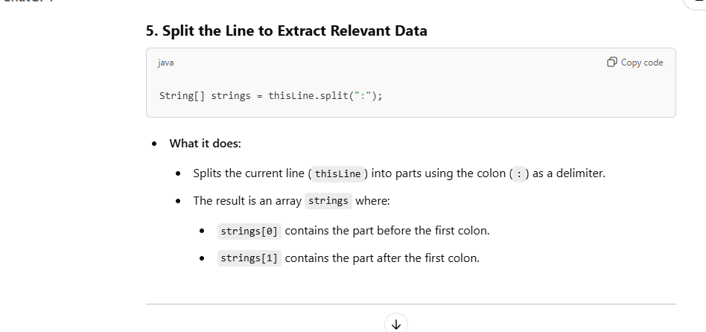

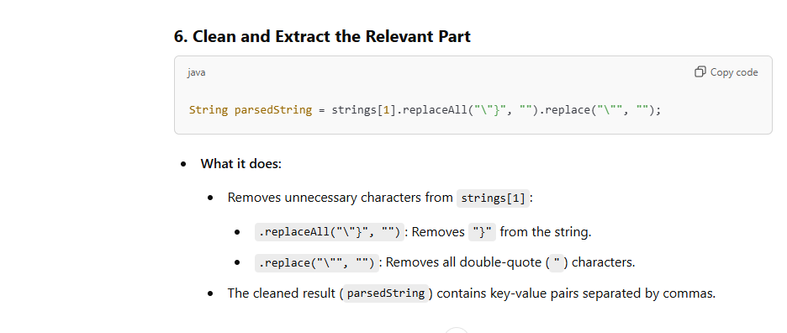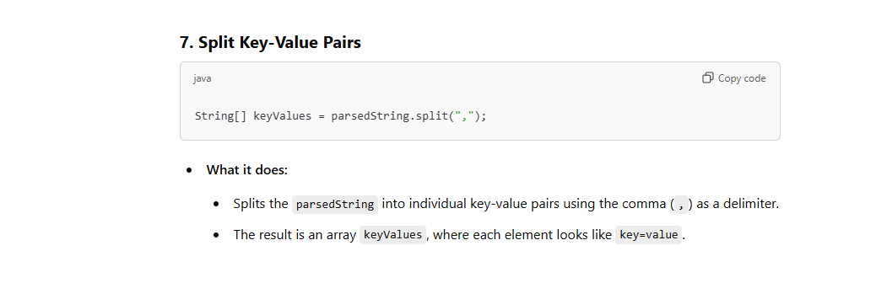

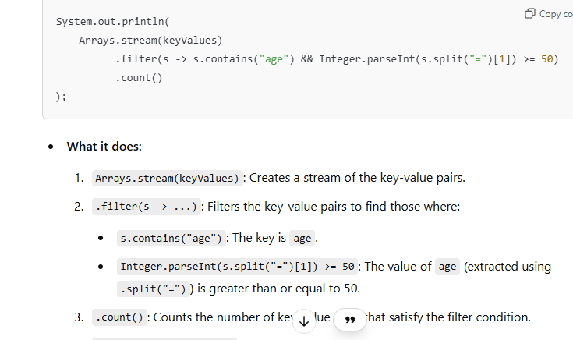

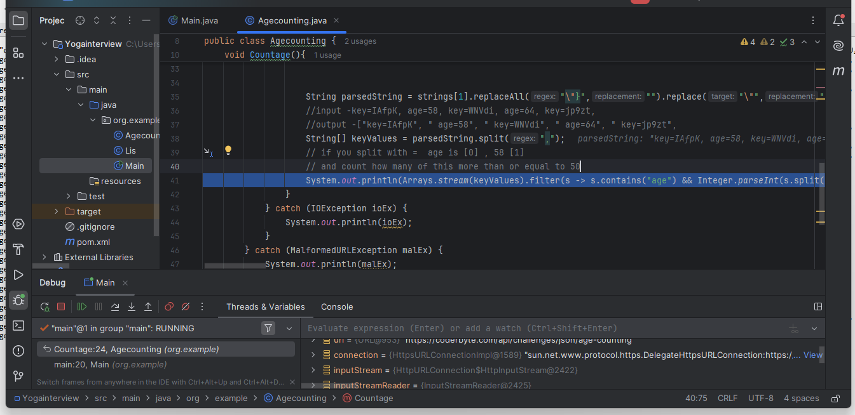

2 nd problem LIS
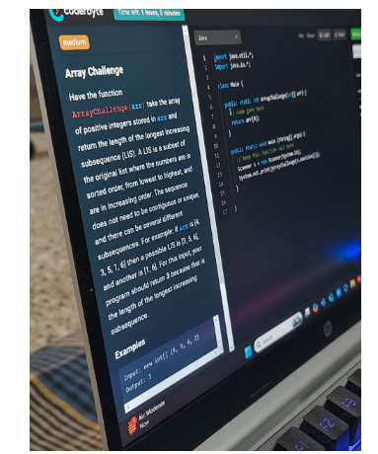
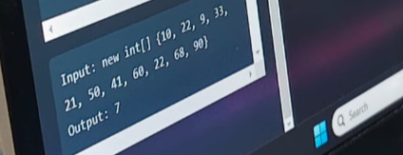

Have the function ArrayChallenge (arr) take the array of positive integers stored in arr and return the length of the longest increasing subsequence (LIS). A LIS is a subset of the original list where the numbers are in sorted order, from lowest to highest, and are in increasing order. The sequence does not need to be contiguous or unique, and there can be several different subsequences. For example: if arr is [4, 3, 5, 1, 6) then a possible LIS is [3, 5, 6], and another is [1, 6]. For this input, your program should return 3 because that is the length of the longest increasing subsequence.
The sequence does not need to be contiguous or unique, and there can be several different subsequences. What is this means?

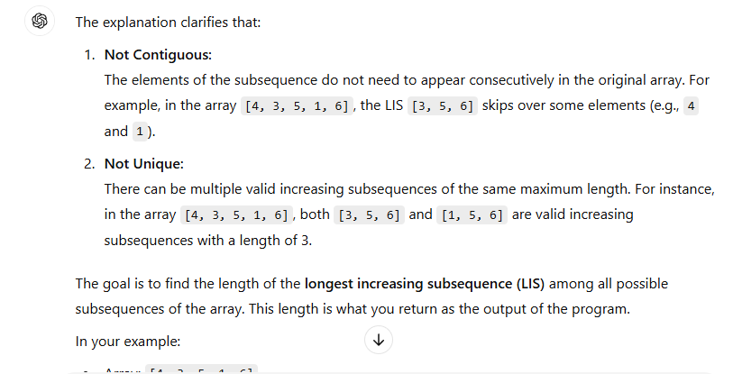

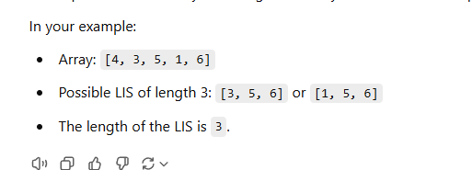

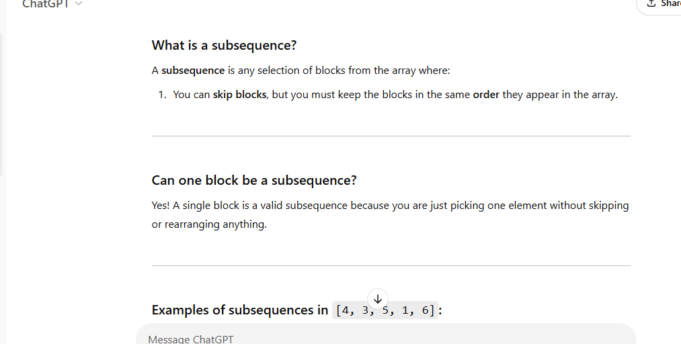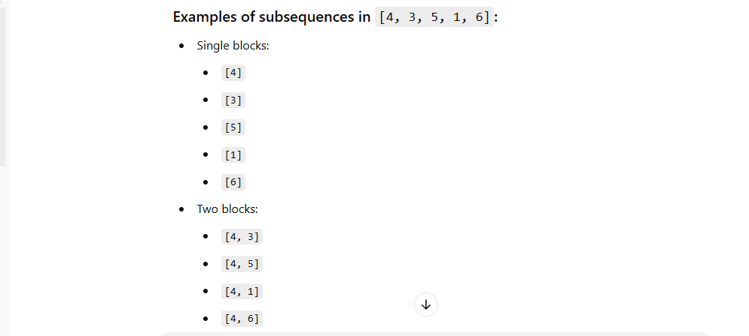
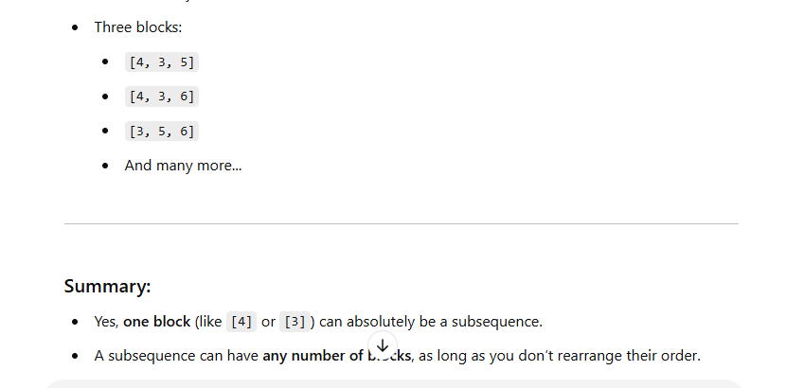
LIS
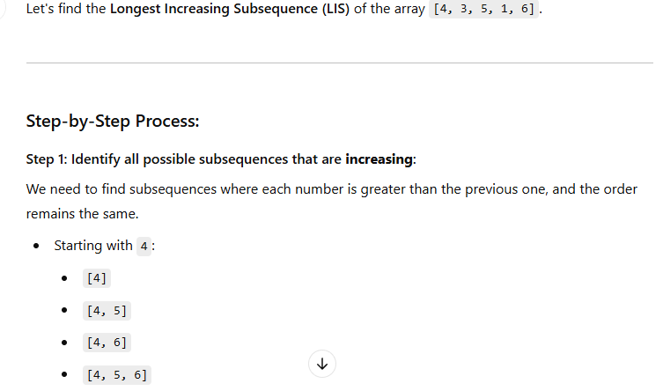

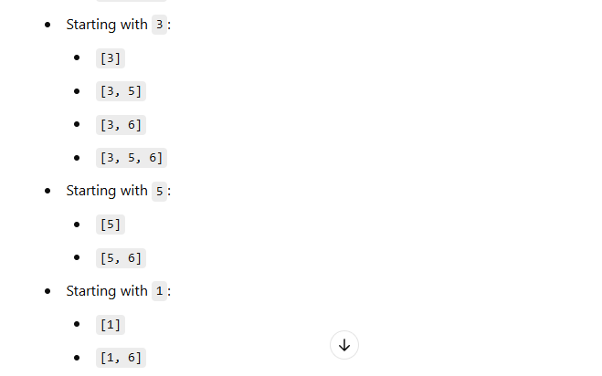
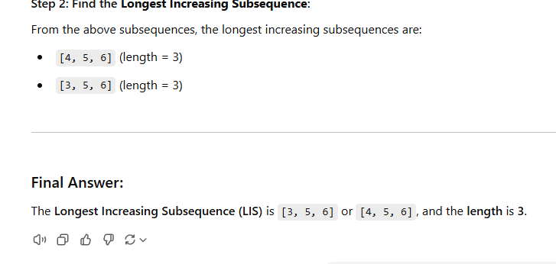

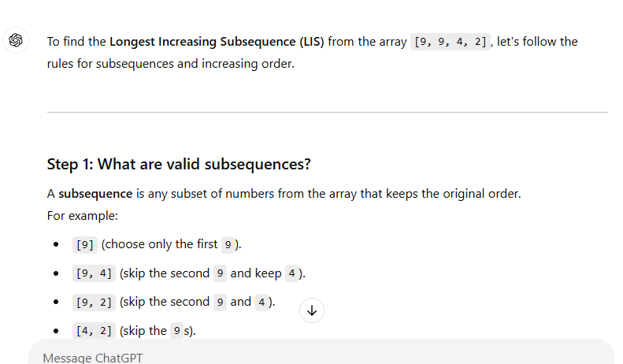

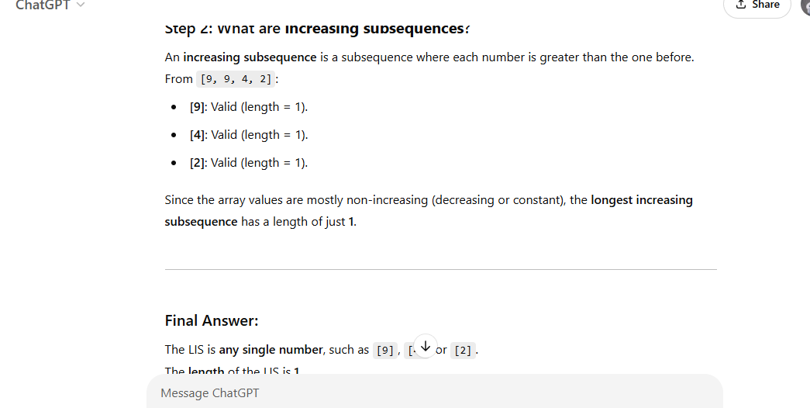

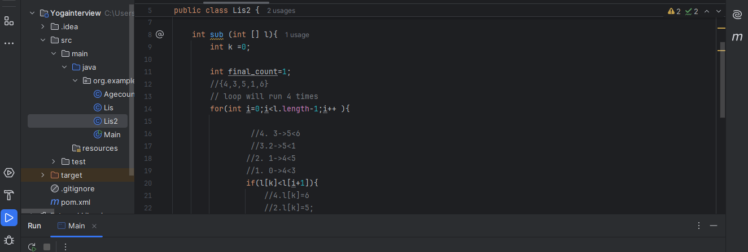
3. Creative Sum

You are given three integers N, X and Y.

Find the sum of all numbers in the range(1,N] which are not a multiple of X or Y

Function description
Complete the calcSum function in the editor below. It has the following parameter(s):
Name is N Type is INTEGER Description is The range of integers

Name is X Type is INTEGER Description is The given of integers X

Name is Y Type is INTEGER Description is The given of integers Y

Return

The function must return a LONG denoting the sum of all numbers in the range[1,N]which are not multiply of X or Y

Constraints
1≤N≤ 10^9

•1≤x≤ 10^9

1≤Y≤10^9
Input format for debugging

The first line contains an integer, N, denoting the range of integers

* The next line contains an integer, X, denoting the value of X described in the problem.

* The next line contains an integer, Y, denoting the value of y described in the problem.
Sample Testcases
Input

5

7

4
Output
11

Output Description

Here all the numbers are [1,2,3,5]

Input
3
4
2
Output
4
Output Description
Here all the numbers are [1,3]
Input
1
1
1
Output
0
Output Description
Here none of the numbers satisfy the given condition.
Give me this logic separately.

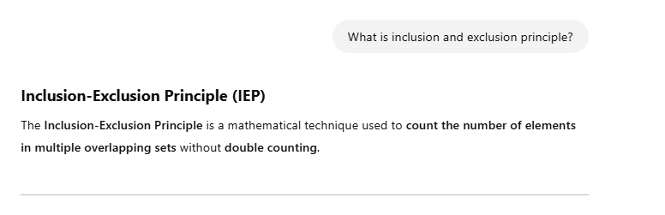

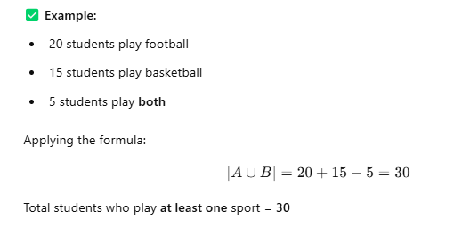

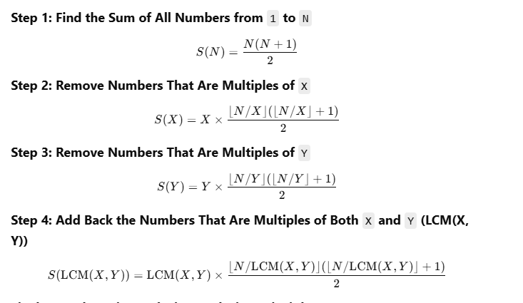


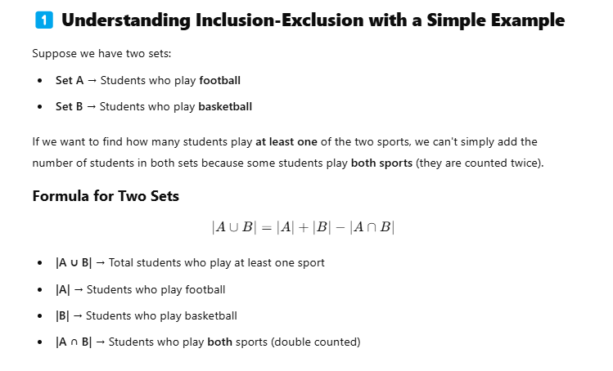
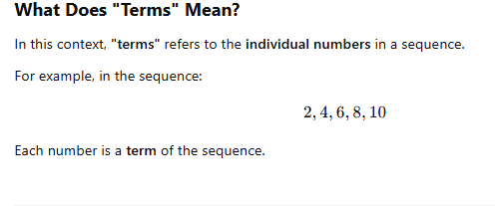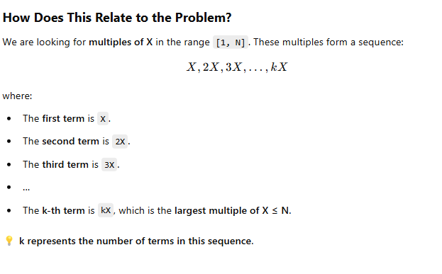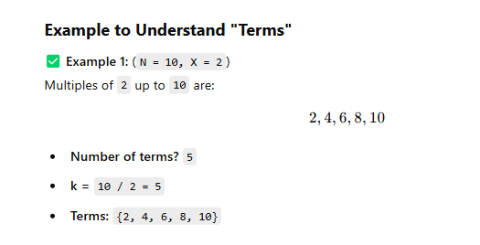

Divisor,Factor both are same 8/2 2 is factor , 9/3 , 3 is the factor
Multiples ->12 = 1,2,3,4,6,12.
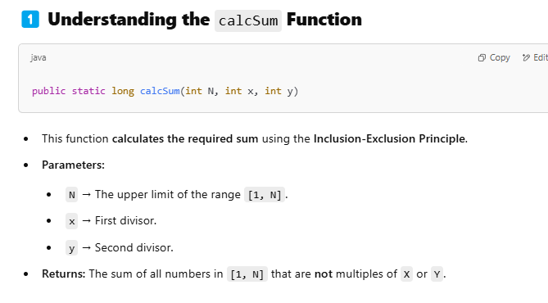
entha formula ella numberum add pani kudthurum
For eg(1to10 )=55
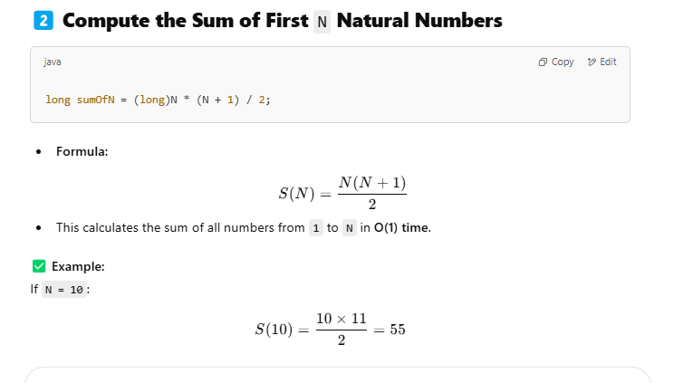
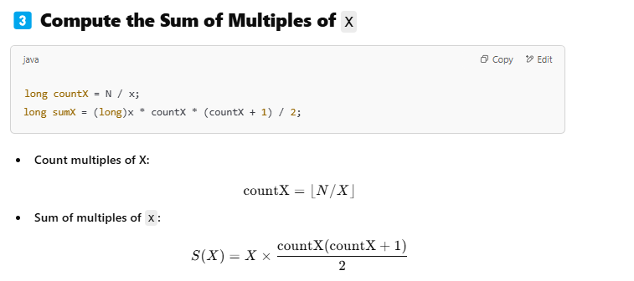
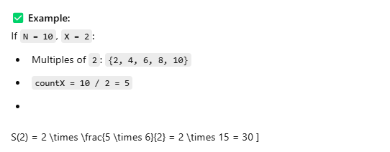

Above formula made like this
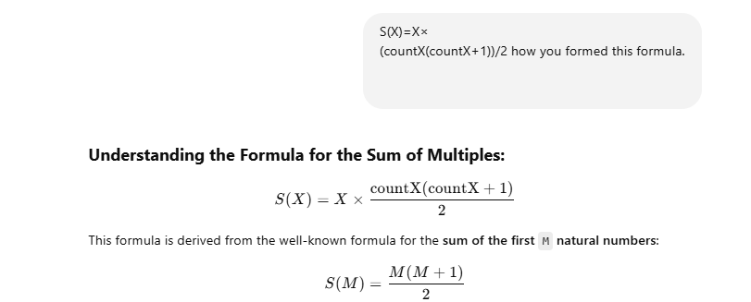
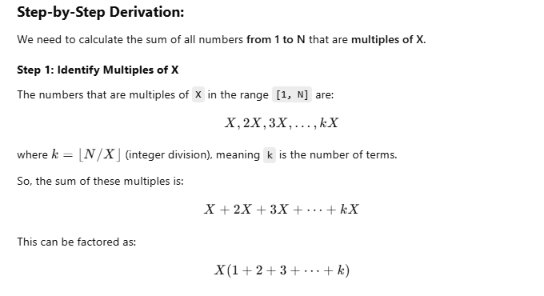
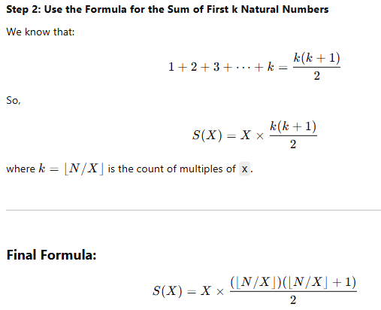
Instead of looping through numbers (O(N)), this formula computes the sum instantly in O(1) time. 🚀
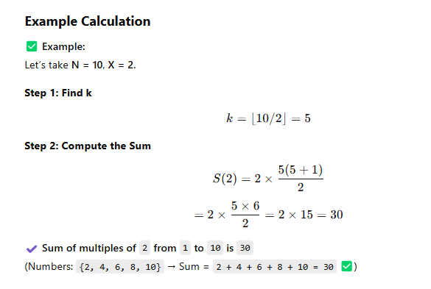
used above one in below formula
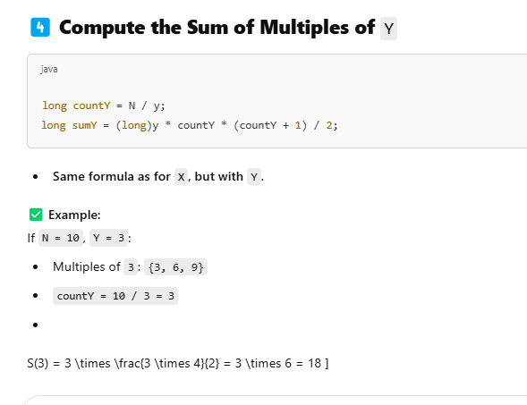
why we find lcm?
3 factors are 3,6,9
2 factor is 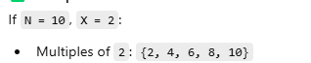
both have two six we need to add only one 6 .but here two 6 is there we need to remove that.
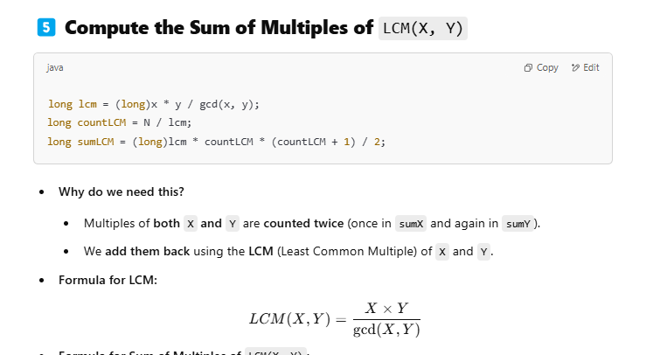
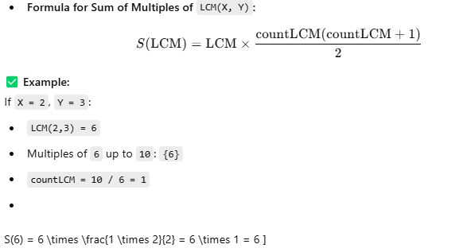

2 multiples 2,4,6,8,10=30;
3 multiples 3,6,9=18;
edhu 6 ha melayum add panurom kelayum add panurom so oru six ha remove pananum nu adhuku than lcm
eradhukum common ha erukurathu 6 athan lcm edukurom. Simple to find common multiple use lcm
Acutal ha eppidi than pananum
input [1,2,3,4,5,6,7,8,9,10]
First x oda multiple=2,4,6,8,10
Second y of multiple 6 add panala en na mela add panitom.3,9
1+5+7 =13
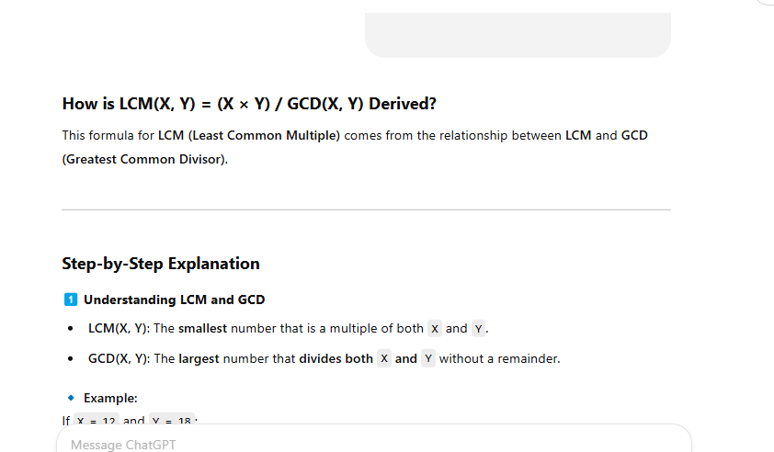
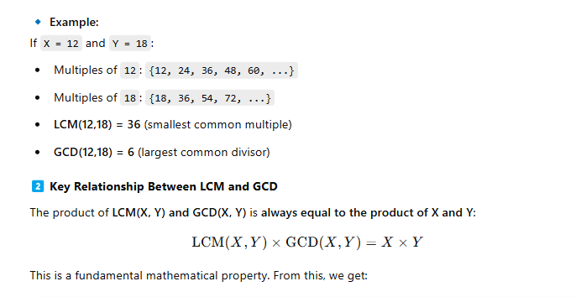

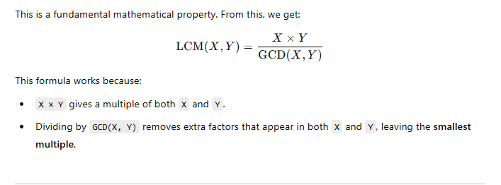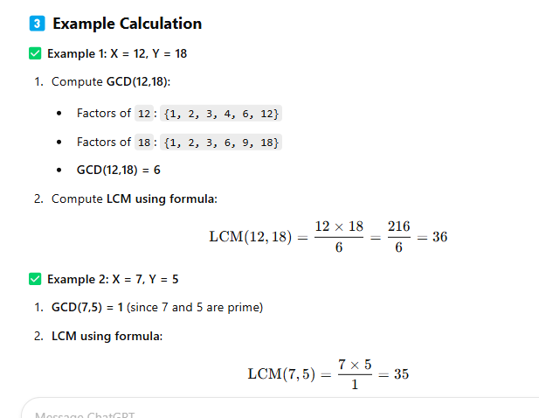
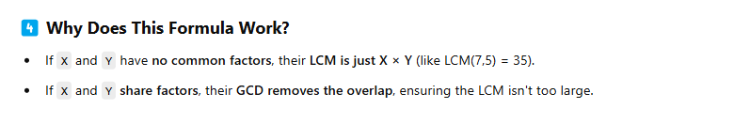
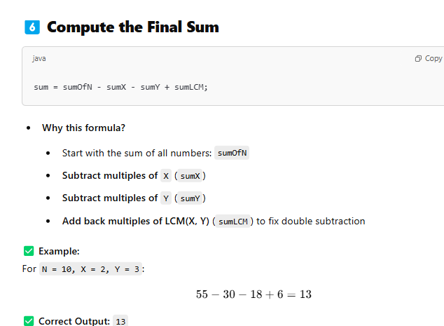
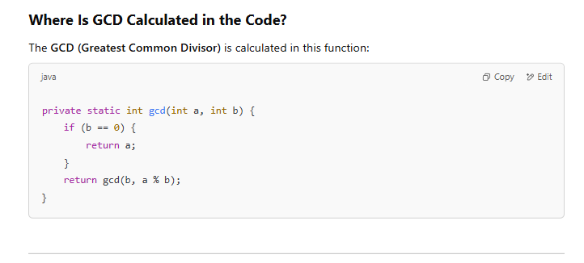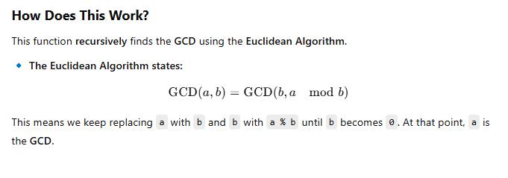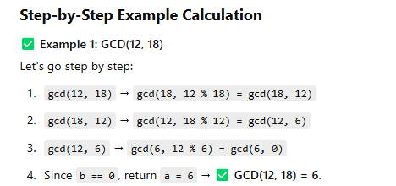

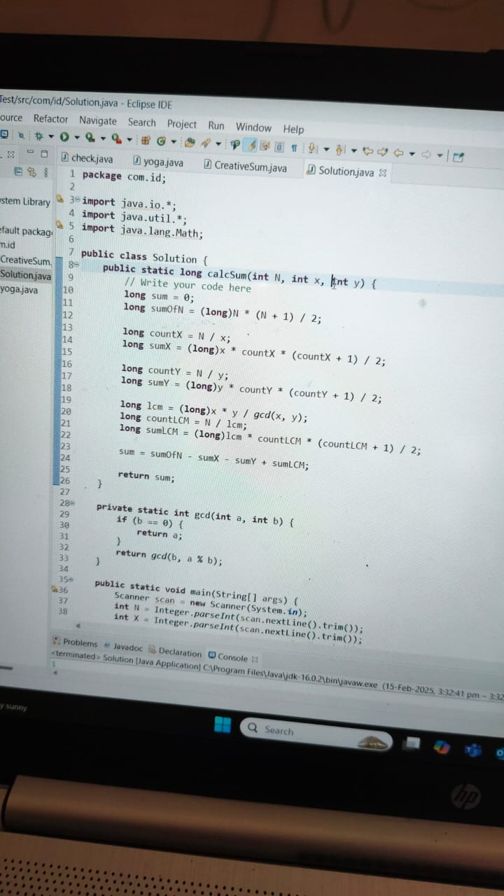
4.
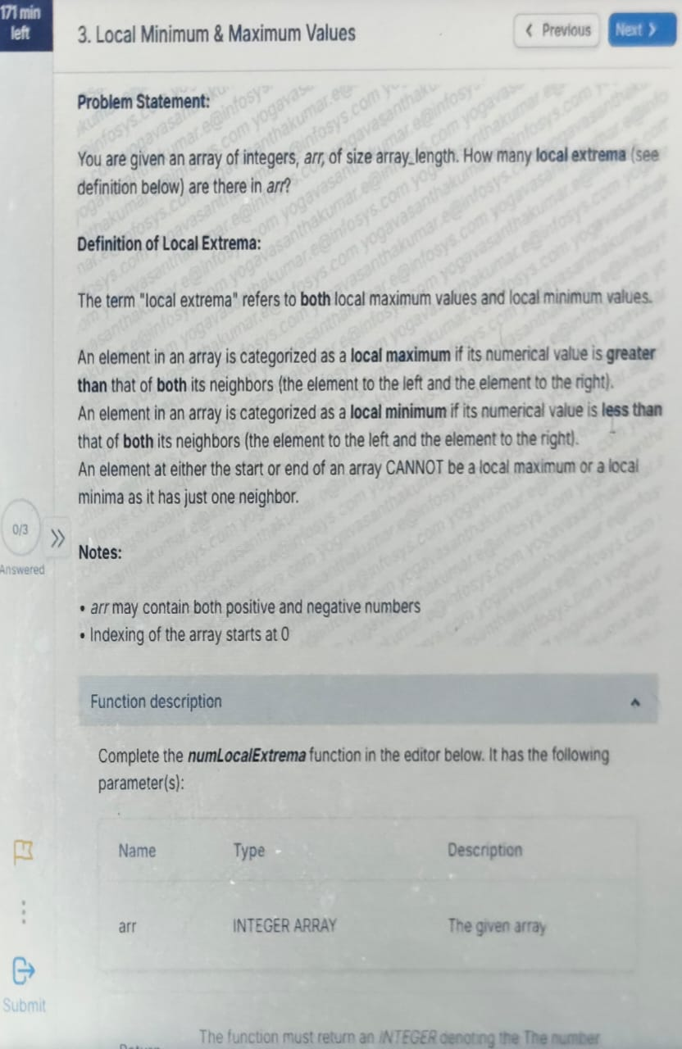

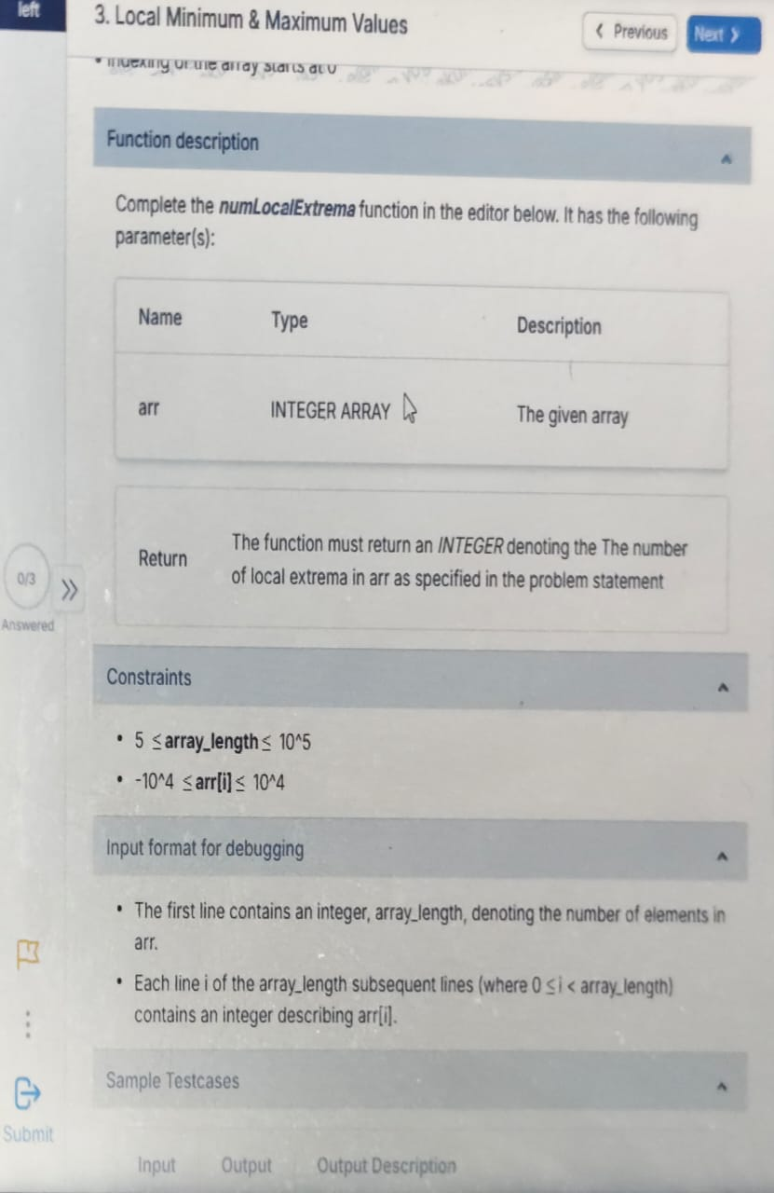

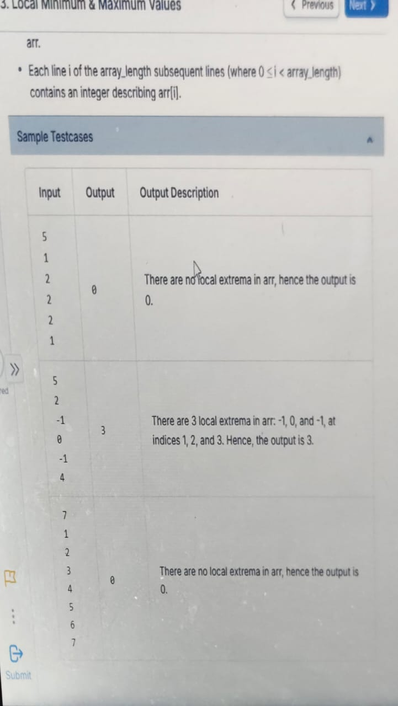
Coding sinpet
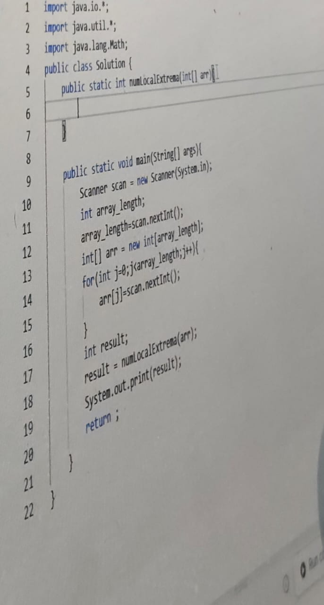

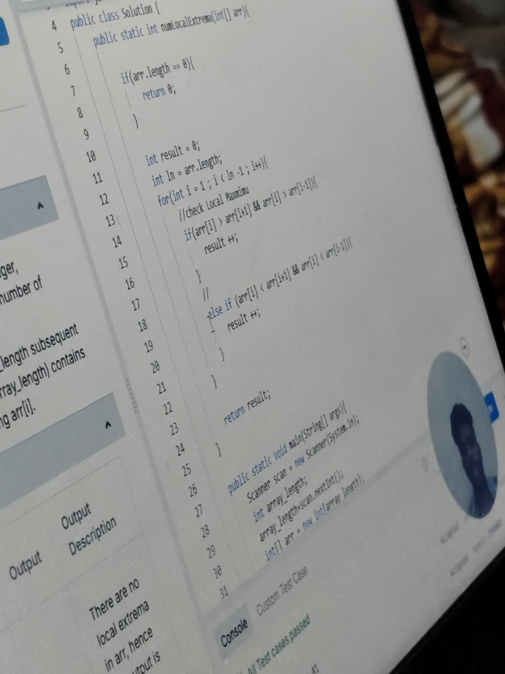
Logic
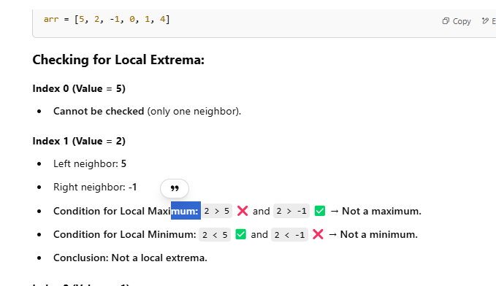 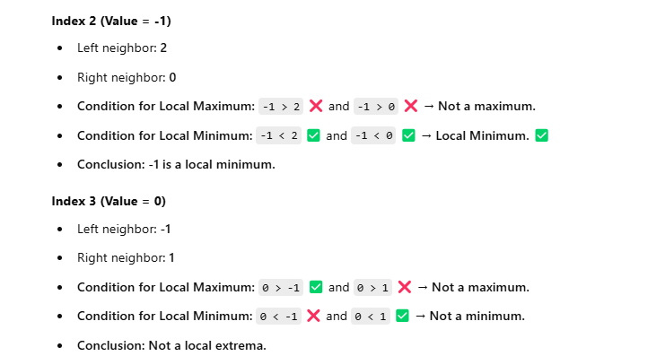
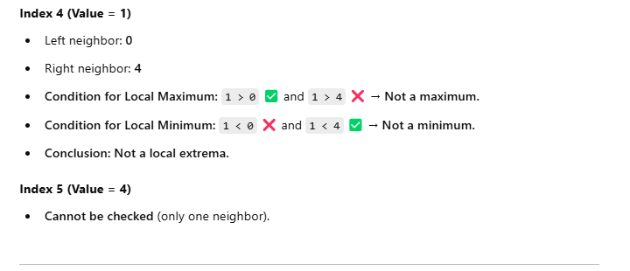

Finally add all the maxima and minimum
Final Answer:
- Local Minimum: -1 at index 2
- Total Local Extrema = 1

5.
5. qst
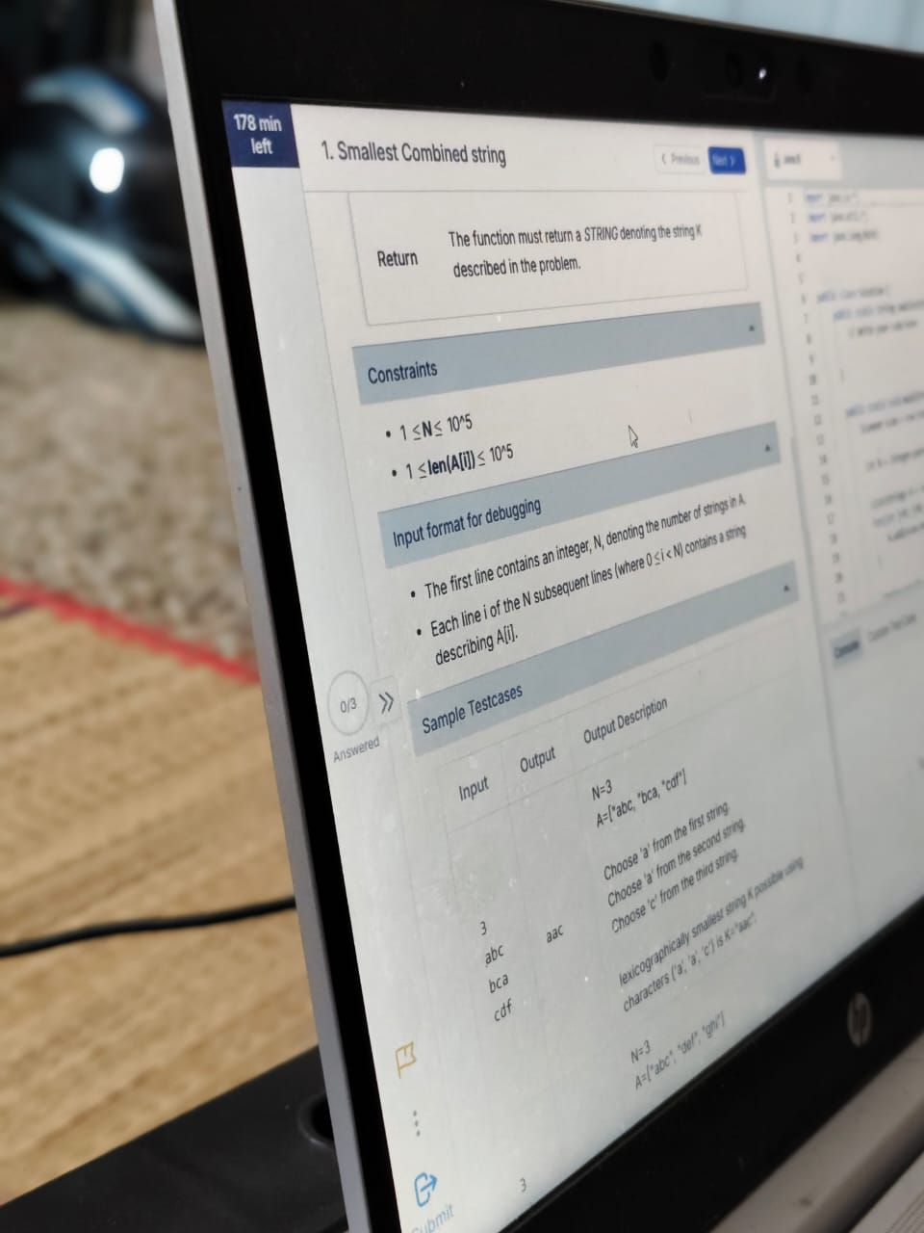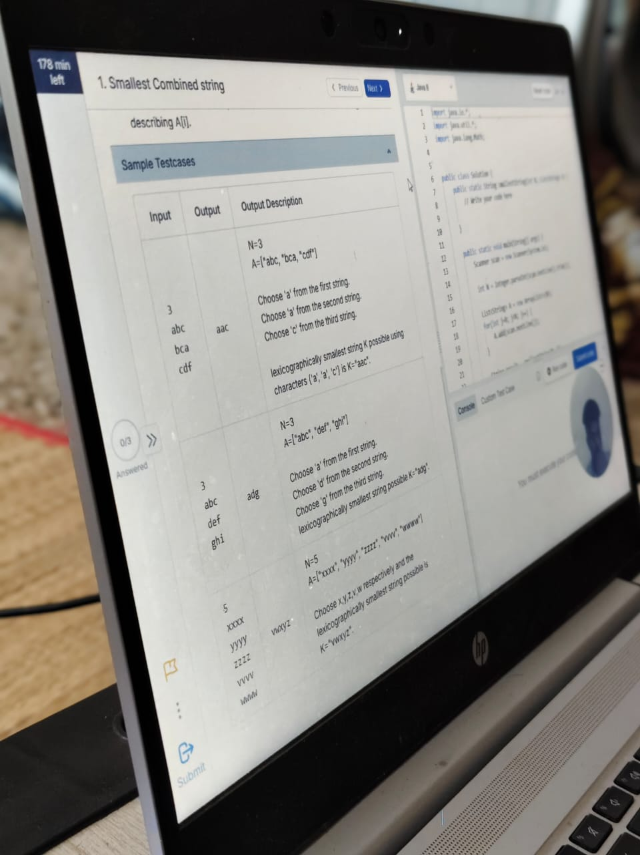

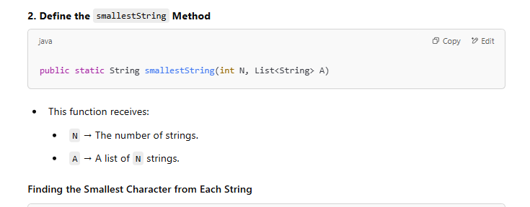
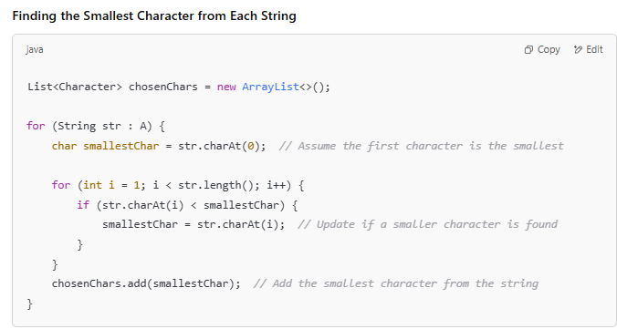
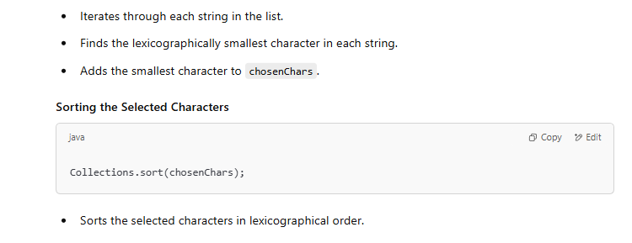
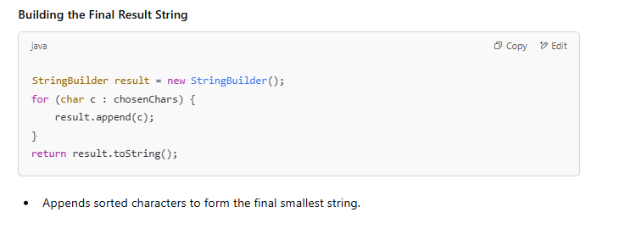

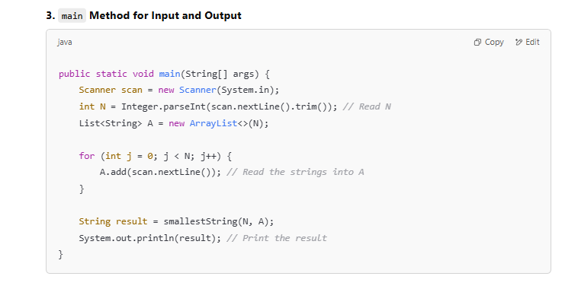
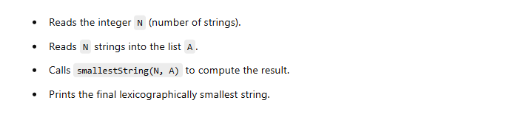

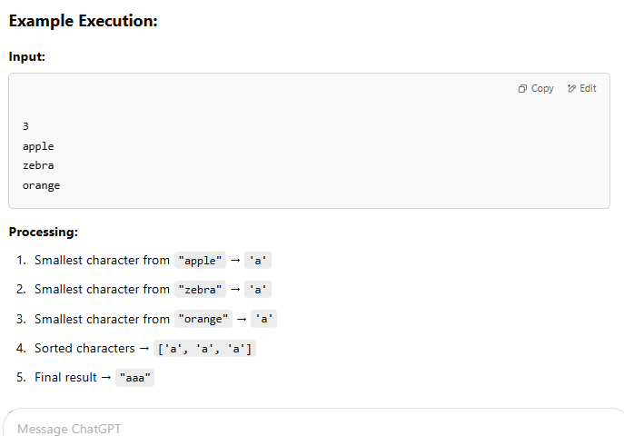

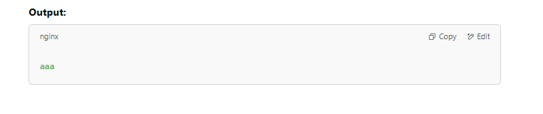

-------------------------------------------------------------------------------






Chatgpt expaanation
https://chatgpt.com/c/67ba75d6-73a0-8001-8e9a-573df42915ab
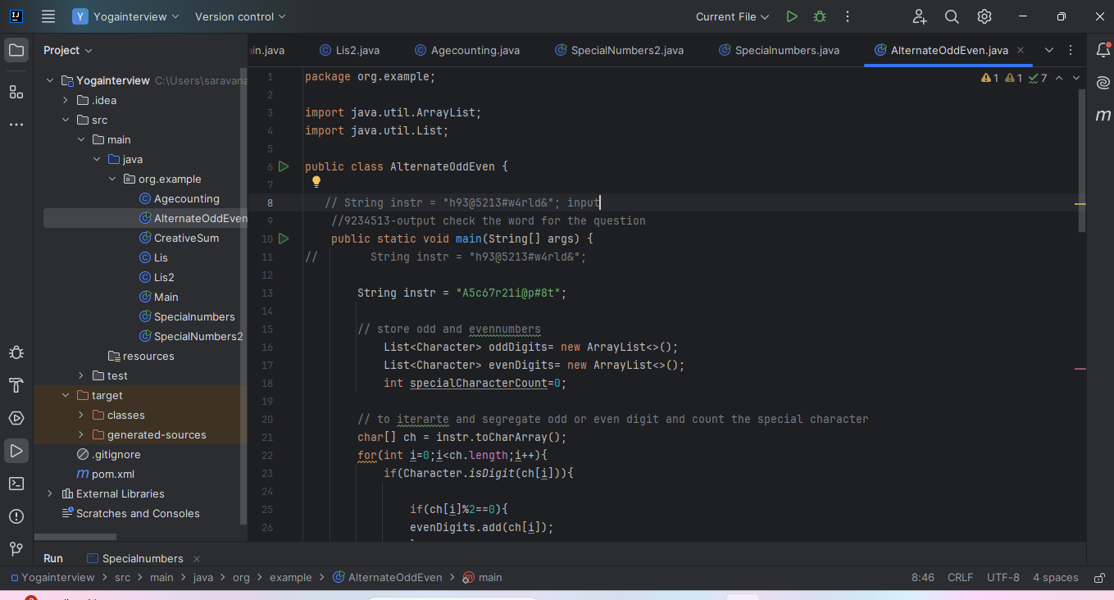

Special numbers

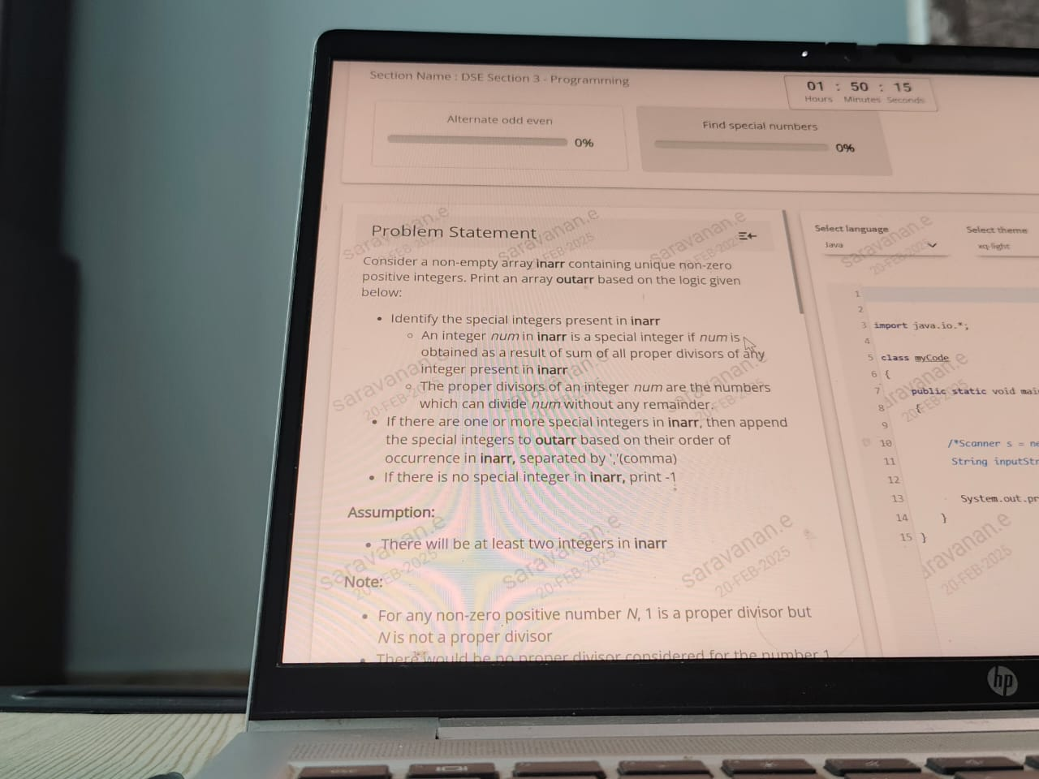









Chatgpt explanation
https://chatgpt.com/c/67b961d9-2ba4-8001-b9b3-41a7094aaadd

Check here coding explanation
